Subject's Name: |  |  | Company:
Employee Number: |  |  | Department:

Has the employee received respirator training? | ☐ | YES | ☐ | NO
Has the employee been medically cleared to use the respirator identified below? | ☐ | YES | ☐ | NO

Type of Fit Test equipment used: |  | ☐ | Irritant Fume |  | ☐ | IsoAmyl Acetate
 |  | ☐ | Saccharin |  | ☐ | Bitrex

Respirator Tested: |  | ☐ | Small |  | ☐ | XL
 |  | ☐ | Medium |  | ☐ | XXL
 |  | ☐ | Large
Test Results:
1. Facial Characteristic Assessment. Respirators with tight-fitting face pieces may not provide a satisfactory seal with individuals having beards, large side burns or other conditions such as missing dentures, etc. that could interfere with the ability of the respirator to attain an adequate seal. Individuals with this condition should not be tested. Did any conditions described above exist? (Check one)
☐ | YES (Do not continue test. Automatic failure) | / | ☐ | NO. Continue with test.

2. | Sensitivity Test: (Check One): | ☐ | Passed | ☐ | Failed
3. | Fit Test: (Check One): | ☐ | Passed | ☐ | Failed

Respirator Assigned: |  |  | Spectacle Kit Required? | ☐ | YES | ☐ | NO

Test Administrator Signature: |  |  | Date:

Employee Signature: |  |  | Date:

Safety Service by:

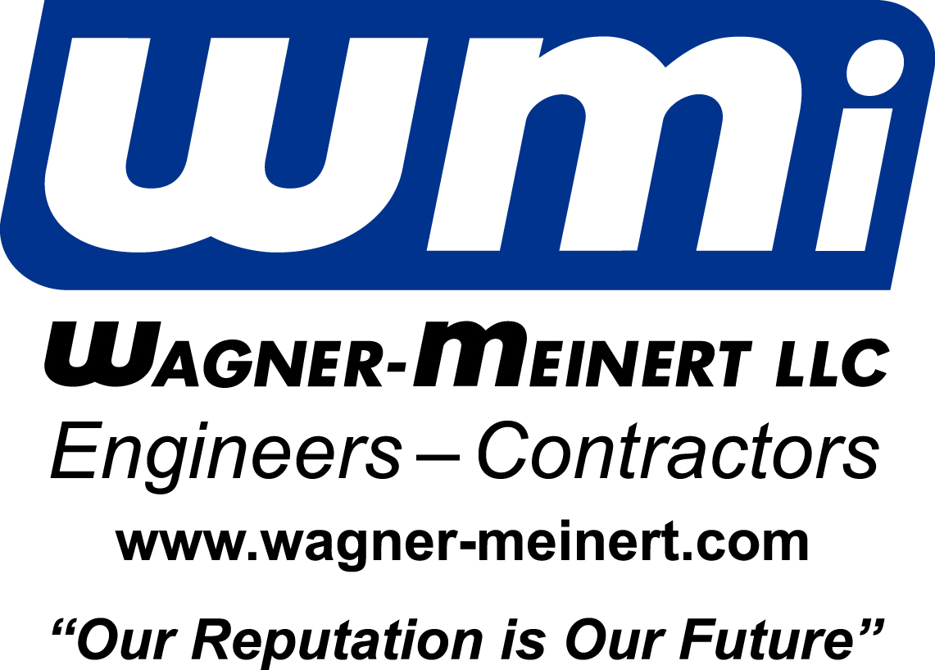

This is to certify that ________________________
_ Has been trained in the use, limitations, and
maintenance of the following Respirator(s).
_ Has passed a Qualitative Fit Test with the following Respirator(s). _ MSA Ultra Twin _ MSA Ultra Elite
_ MSA Advantage 1000 _ MSA Advantage 3000
_ MSA Advantage 3200 _ MSA Advantage 4000
_ North 5400 Series _ North 7600 Series
_ Scott Scott-O-Vista _ Sm _ Med _ Lg
_ Other _____________________ _ XL _ XXL
Expiration Date ______________ Test Date________
Instructor __________________________________

7617 Freedom Way Fort Wayne, Indiana 46818

